This semester, I’m planning to build the lab directly in Canvas. Therefore, there is no need to make this pretty at this point. Just get everything written down here as a backup and for taking notes.

General Notes/Ideas:

* They should be able to complete the lab in about 2 hours.
* For the lab, maybe just have them look up an article, or maybe give them an article. Yes, give them an article so that you know ahead of time what the DAG should look like. And have them draw a DAG.
* Sketch out a component cause diagram.
* Have them articulate the complementary strengths of DAGs and the Sufficient-Component Cause model.
* Have them discuss individual causal effects and population average effects.
* Which intervention should we choose? RR vs AR? Use the example from GPLI.
* How do we represent bidirectional relationships in DAGs?

# Current Version:

Instruction: Please complete the following lab assignment. You may work on the assignment in groups or on your own. However, to get credit, you must submit your own answers in Canvas. This lab is open note and open book. You may also ask the instructor and the TA questions. Please note that in most cases we will try to guide you towards answering your own question rather than directly providing you with an answer.

1. Insert a DAG using [Google Draw](https://docs.google.com/drawings/d/1vOKJSKIV9Juj82TtwPbJDWO1poMWogT8ZutaHfgbaEA/edit)



2. Insert an Equation

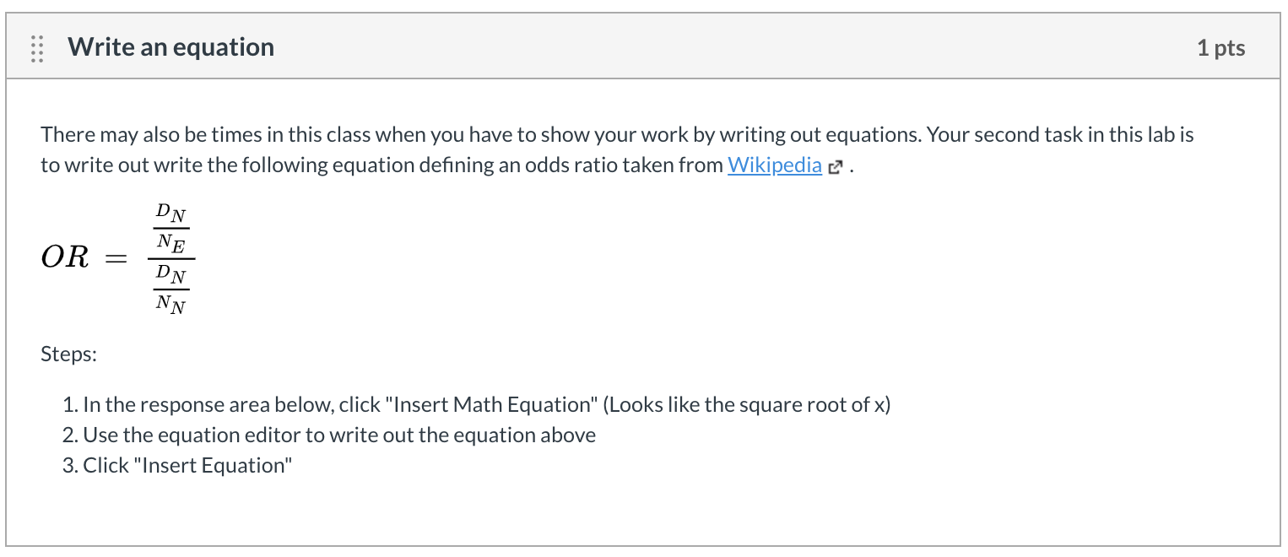

3. Choose one disease or health-related outcome that interests you most. Below, you will look up information about that disease or outcome and use that information to answer a few questions. What disease or health-related outcome did you choose?

4. Do some independent research. Identify multiple component causes for this outcome. Be sure there is at least some epidemiologic evidence that links these risk factors to your disease or health outcome of interest. This can include any type of observational study(ies) (e.g., cross-sectional, case-control, cohort, etc.). Is each component cause proximal, intermediate, or distal to your outcome?

5. Create at least three sufficient cause sets (i.e., causal mechanisms) out of the component causes you have identified. In doing so, consider whether and how the component causes you include in each sufficient set interact with one another to cause disease. It can be useful to consider specific sub-groups to which each sufficient cause set may apply. Illustrate your causal mechanisms and explain them. I’ve recreated Figure 10-1 from your textbook in Google Draw as an example below.

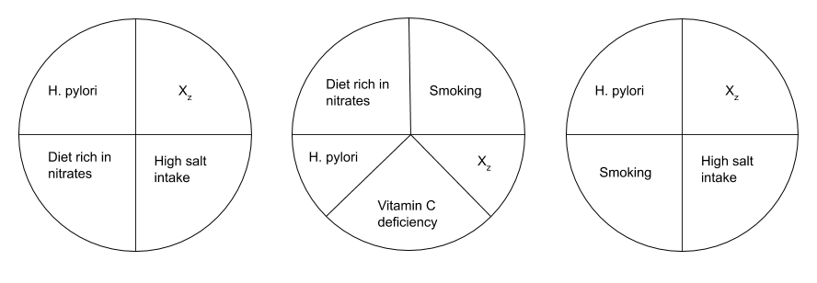

6. Are there any necessary causes for this disease? Are there any necessary causes for this disease? If so, please list them.

7. Consider implications for intervention, given Rose’s perspectives on prevention. Choose one component cause (or sufficient cause set) you identified above. Consider a ‘high-risk strategy’ for intervention. Which individuals comprise the ‘high-risk’ tail of the distribution, given this cause? How would you intervene on these individuals? Name 1 advantage and 1 disadvantage of your approach.

8. Now consider a ‘population strategy’ for intervention. What change(s) in the mean of the risk distribution curve might be meaningful? How would you intervene to achieve this shift(s)? Name 1 advantage and 1 disadvantage of your approach.

# 

# Appendix: Melissa’s discussion post

1. Choose one disease or health-related outcome that interests you most.
2. Apply Rothman’s Sufficient Component Cause model to this outcome of interest.
   1. Do some independent research. Identify multiple component causes for this outcome. Be sure there is at least some epidemiologic evidence that links these risk factors to your disease or health outcome of interest. This can include any type of observational study(ies) (e.g., cross-sectional, case-control, cohort, etc.).
   2. Is each component cause proximal, intermediate, or distal to your outcome?
   3. Create at least three sufficient cause sets (i.e., causal mechanisms) out of the component causes you have identified. In doing so, consider whether and how the component causes you include in each sufficient set interact with one another to cause disease. It can be useful to consider specific sub-groups to which each sufficient cause set may apply. Illustrate your causal mechanisms and explain them.
   4. Are there any necessary causes for this disease? Also, are there other potential component causes for which evidence is either unavailable or might be ‘weak’? What component causes might be missing from epidemiologic evidence to date?
   5. Try to locate any evidence for attributable risk specific to any of the component causes above. Which causes are the most important to consider in an intervention.
3. Consider implications for intervention, given Rose’s perspectives on prevention.
   1. Choose one component cause (or sufficient cause set) you identified above.
   2. Consider a ‘high-risk strategy’ for intervention. Which individuals comprise the ‘high-risk’ tail of the distribution, given this cause? How would you intervene on these individuals? Name 1 advantage and 1 disadvantage of your approach.
   3. Consider a ‘population strategy’ for intervention. What change(s) in the mean of the risk distribution curve might be meaningful? How would you intervene to achieve this shift(s)? Name 1 advantage and 1 disadvantage of your approach.
4. Finally, if you have any questions specific to the material in the Module, please ask here.

# Appendix: Miryoung’s assignment 1.3 questions

| In terms of disease prevention, it is necessary to understand causal mechanisms between risk factors and outcomes in their entirety. | | |
| --- | --- | --- |
|  | True |  |
| X | False | Knocking out even one component cause prevents all sufficient causes with that component cause. |

| Factor A, B, C, D can individually cause a certain disease without the other three factors but only when followed by exposure to factor X. Exposure to factor X alone is not followed by the disease, but the disease never occurs in the absence of exposure to factor X.  According to the causal model described above, factor C is: | | |
| --- | --- | --- |
|  | A necessary and sufficient cause |  |
|  | A necessary but not sufficient cause |  |
|  | A sufficient but not necessary cause |  |
| X | Neither necessary nor sufficient |  |
|  | None of these |  |

| Factor A, B, C, D can individually cause a certain disease without the other three factors but only when followed by exposure to factor X. Exposure to factor X alone is not followed by the disease, but the disease never occurs in the absence of exposure to factor X.  According to the causal model described above, factor X is: | | |
| --- | --- | --- |
|  | A necessary and sufficient cause |  |
| X | A necessary but not sufficient cause |  |
|  | A sufficient but not necessary cause |  |
|  | Neither necessary nor sufficient |  |
|  | None of these |  |